OVERALL PROGRAMME EVALUATION REPORT
SBVP ALUMNI MASTERCLASS Online s Module 2 Kenya: (4th May 2026 - 8th May 2026)
No. of Respondents: 155
No. of Participants: 155
Response Rate: 100%
--------------------------------------------------

Faculty Reports

Dr. Mary Moraa Aminga - From Impact Measures to Long Term Sustainability Planning
Evaluation Parameter | (%) Individual Score | (%) Programme Average
Punctuality (Commencement and Completion of Sessions) | 98 | 95
How well do you understand the core concepts presented? | 88 | 90
Rate your confidence in applying the new skills learnt | 86 | 85
Degree of Faculty preparedness for the sessions | 99 | 96
Content and methodology of the program | 92 | 93
Quality of class and group discussions | 88 | 90
The information presented in the course is relevant to my work (ministry) | 94 | 94
Average scores | 92 | 92

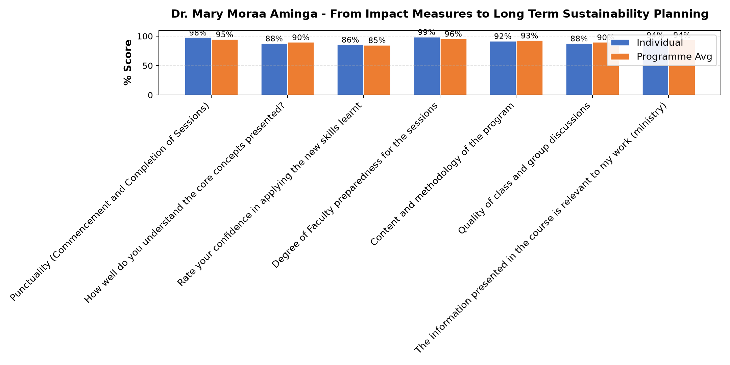

Comments & Feedback
- • I need someone to mentor me at the start-up time.
- • Limited resources for growth strategy
- • Financial instability
- • Insufficient resources
- • The unfinished projects that we are still working on
- • Excellent
- • Resources and Poor planning

Dr. Mary Moraa Aminga - Long-term sustainability planning
Evaluation Parameter | (%) Individual Score | (%) Programme Average
Punctuality (Commencement and Completion of Sessions) | 96 | 95
How well do you understand the core concepts presented? | 93 | 90
Rate your confidence in applying the new skills learnt | 89 | 85
Degree of Faculty preparedness for the sessions | 96 | 96
Content and methodology of the program | 95 | 93
Quality of class and group discussions | 91 | 90
The information presented in the course is relevant to my work (ministry) | 95 | 94
Average scores | 94 | 92

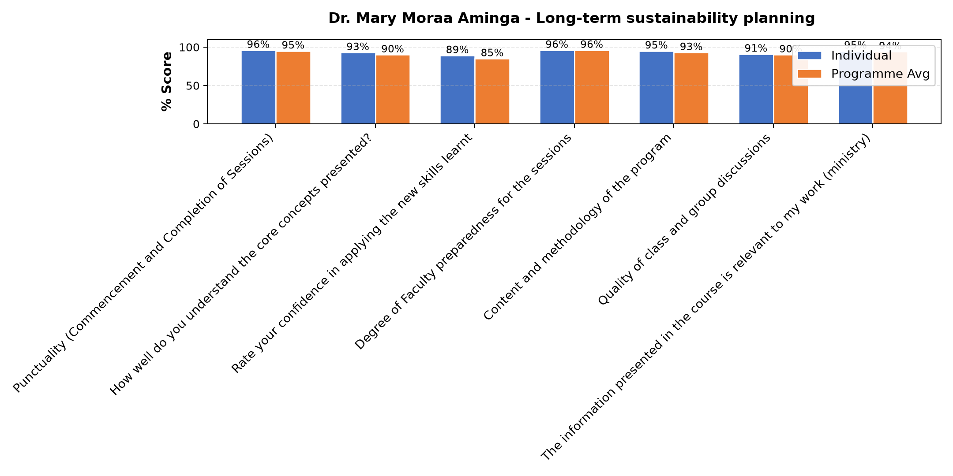

Comments & Feedback
- • The process of decision making takes long to implement something
- • Finance
- • The knowledge recieved is good enough to start applying the skills where possible
- • Lack of putting what have learned into practice.
- • Experience
- • The collection of data
- • Lack of important data for monitoring and evaluation of social impact
- • Financial problem and competition.
- • Uncertainty of resources mobilization
- • Well presentation

Dr. William Murithi - Review (identify gaps/challenges) your business Canvas from module || Decide key issues for long-term sustainability || Identify areas where support is needed
Evaluation Parameter | (%) Individual Score | (%) Programme Average
Punctuality (Commencement and Completion of Sessions) | 92 | 95
How well do you understand the core concepts presented? | 89 | 90
Rate your confidence in applying the new skills learnt | 81 | 85
Degree of Faculty preparedness for the sessions | 93 | 96
Content and methodology of the program | 91 | 93
Quality of class and group discussions | 92 | 90
The information presented in the course is relevant to my work (ministry) | 92 | 94
Average scores | 90 | 92

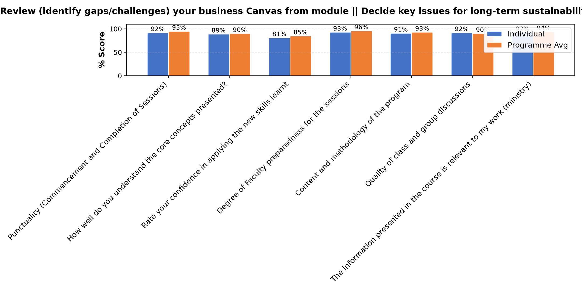

Comments & Feedback
- • Financial constraints
- • Finance issue
- • Making decisions on when the work should start because of financial constraints
- • Nothing
- • Lack of expert support
- • Financial constraints for implementation
- • Financial resources
- • Delayed decisions and fear of taking financial risks. Talent deployment mismatch and poor strategy on the utilisation of resources

Department Reports

Are there any other comments and/or suggestions that you may want to add?
Evaluation Parameter | (%) Score
Punctuality (Commencement and Completion of Sessions) | 100
How well do you understand the core concepts presented? | 80
Rate your confidence in applying the new skills learnt | 80
Degree of Faculty preparedness for the sessions | 60
Content and methodology of the program | 80
Average score | 80

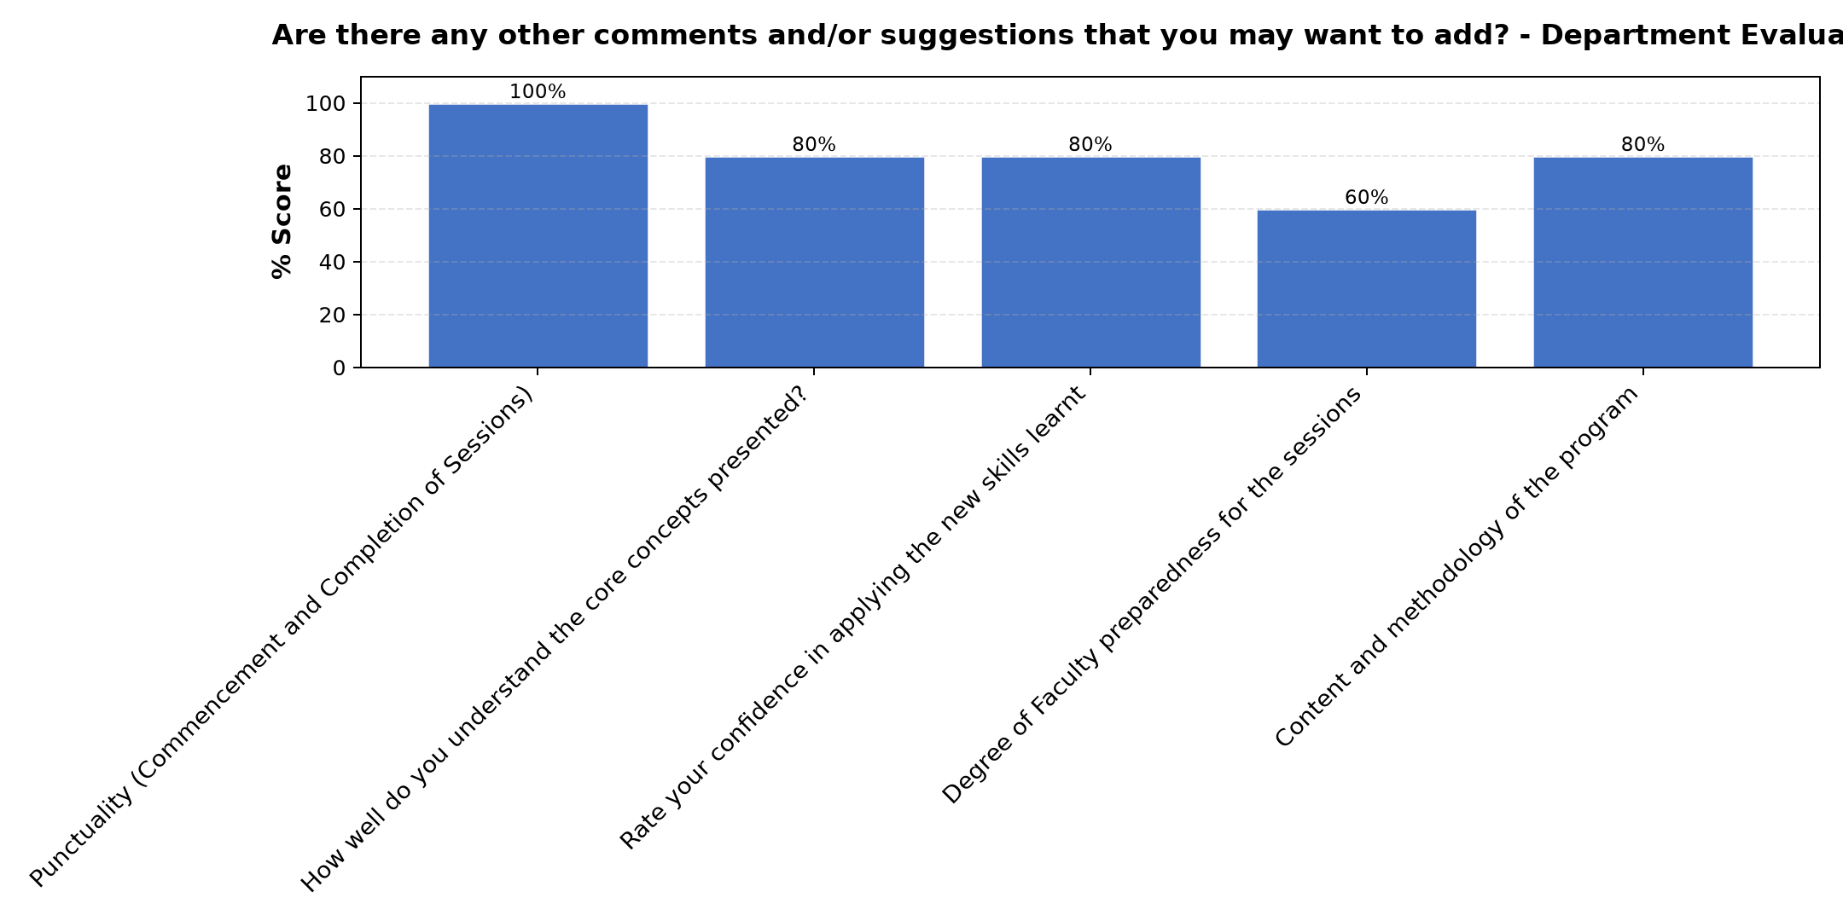

Comments & Feedback
- • Thanks for planning this course , how I wish other members of our congregation can go through the same especially those running our projects.
- • I just want say thank you for good work and continue in that spirit of service with a lot of humility. Am humbled .
- • God bless Hilton Foundation, ACWECA,STRATHMORE and all who were behind such a beautiful program
- • Thank you for accommodating us in this program
- • All the facilitators were wonderful and knowledgeable
- • Thank you for the organization and delivery of the entire program. Thanks to our sponsors
- • Pay us a visit in our enterprises and advise us on where to improve.
- • Strathmore is very organized in delivering the learning

Further Comments

Comments & Feedback
- • To get the donners is not easy. Many proposal are rejected but continue searching
- • The class was interactive and I was able to understand parts which I had not understood and be able to look things from a different perspective
- • I know what I didn't know before
- • But the strategies shared by all has created more determination to bringing the social enterprise to my dream
- • The facilitator prepared well in engaging us for future plans.
- • Thanks alot for this opportunity
- • It was great, and very practical!
- • If possible the identified gaps to be followed up by visiting our enterprises. You will discover more than what we have identified.
- • Well done
- • We pray pray that our social enterprise will be sustainable for the source of income for our community, and the people round us more so the youth who are jobless.
- • Thank you for the lessons on the way forward for our Social enterprises

Further Comments

Comments & Feedback
- • Well presented
- • It was good
- • The 3ps are very key in our enterprises for long term sustainability.
- • Thank you for the enlightenment on green sustainability
- • Was difficult to understand the case study
- • It was very insightful, how to use resources in a way that posterity is not cheated out! There was a slant in looking at sustainability, going green can significantly cut costs in the long run and thinking green brings about innovations which informs our present decisions and spans into the future
- • I am so grateful to Dr. Aminga, her competency is recommendable
- • We'll presentation
- • Thanks for providing the best knowledge able facilitators
- • Well done
- • Excellent
- • The content delivered was good but needed more time to grasp it well.
- • To try to define the challenges of our time.

Further Comments

Comments & Feedback
- • The topic was well understood
- • Good input but more time required
- • My takeaway lesson, I have discovered that no matter what I do, if there is no proper planning, monitoring, and evaluation, then I am going nowhere. Also, I have learned that as much as I want to increase my income, I should also bring a positive social impact to the beneficiaries. Now, the greatest challenge in our social enterprises as LSSJ is luck of proper planning, monitoring and evaluation. (Discovered today)
- • Lesson was interesting
- • She is selective in response to students contributions. She can make one feel that you are wrong.
- • I really enjoyed the class... Social impact I discovered is an untapped resource that can really inform the enterprise and propel the enterprise forward
- • Thank you very much for the inspiration and challenge to measure our Social Enterprises Social impact qualitatively and quantitively
- • The presentation was very interesting and educative
- • Monitoring is key and should be done gradually
- • Now to succeed in our social interprise we are to plan smart in order to produce quantity and quality product.
- • The content was delivered well and summarised for easy understanding.
- • Good presentation, recommend her for future classes
- • Keep it up

Overall Evaluation
Evaluation Parameter | (%) Score
Overall program evaluation | 97
Average score | 97

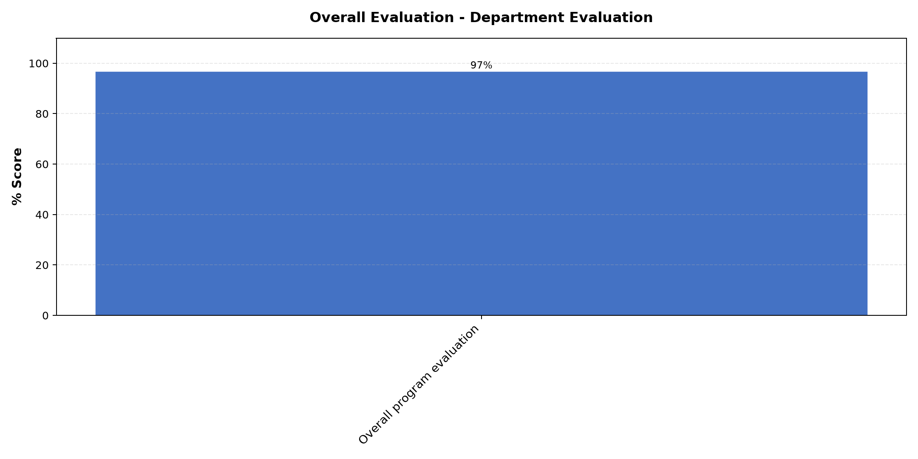

Comments & Feedback
- • All
- • Sustainability, marketing
- • Working on sustainability and scaling up
- • Social impact measures and planning
- • Planning for financial growth and sustainability
- • All was important
- • Social impact measures and planning
- • Social Impact measurement and the Sustainability planning
- • The fundraising aspect different ways of diversifying our funds for sustainability
- • Monitoring and funding plans.
- • Financial & Long term sustainability plan
- • Mission algnment

Program Manager (Sr. Felister Kizia)
Evaluation Parameter | (%) Score
Punctuality (Commencement and Completion of Sessions) | 100
How well do you understand the core concepts presented? | 100
Rate your confidence in applying the new skills learnt | 100
Degree of Faculty preparedness for the sessions | 100
Content and methodology of the program | 100
Average score | 100

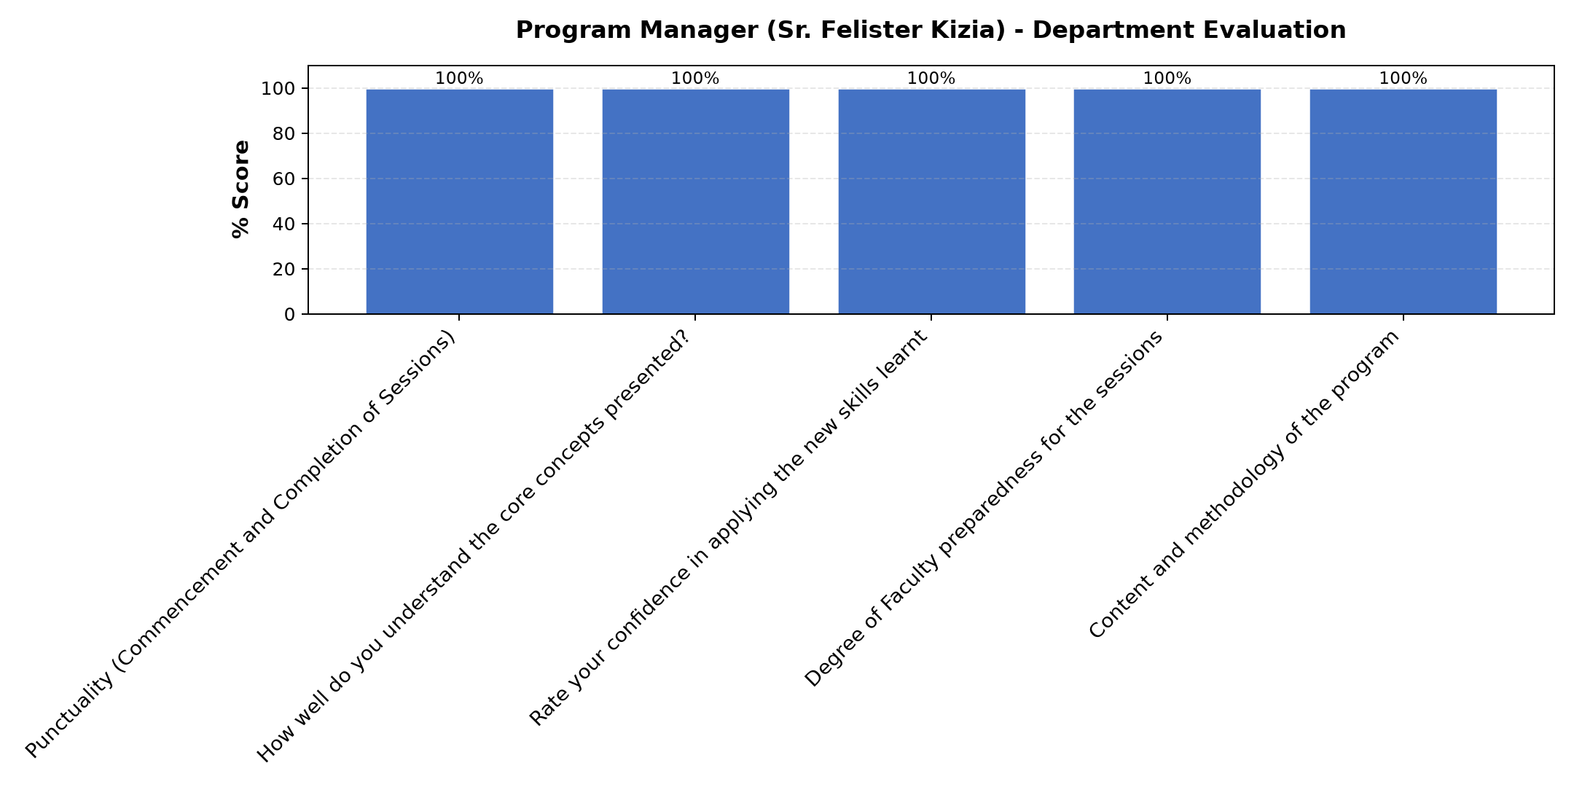

Comments & Feedback
- • Job well done may God bless you ,you just equal to the task
- • Always ready for service either for clarity, a question or giving information with follow up.
- • I feel grateful for being part of the team
- • I understand this is an online program but I still feel we need to have a day where we can come and meet and share our issues physically it will add more value
- • Task excellently done
- • Well organised and attentive in all the sessions.
- • Well focused and oriented to the programne
- • Equal to the task , thanks for your coordination may God bless you
- • The input given was very good to help us to plan smart in our various social enterprise.
- • Thank you for facilitating us and we appreciate your support

What attracted you to the programme??

Comments & Feedback
- • The insights given for improving our social enterprise and shared by my sister's who participated previously
- • To sustain our enterprise needs to have a plan, mindset, monitoring in order to see the gaps and improve on them. I have also to take care of our planet, people and the value of the product.
- • The insightful presentations geared towards sustainability and growth
- • The way Srs shared their insights in depth and the openness
- • An invitation through my congregation
- • Scaling up our enterprises for sustainability which is really working.
- • To be able to gain skills and knowledge to expand and run our enterprise well
- • Insights on improving our social enterprise shared by my sister who previously attended the programme
- • It's continuety to the next level.
- • The desire to learn more on how to utilise our resources for long term growth and financial sustainability

What topic would you recommend being expanded/improved in this programme’s units?

Comments & Feedback
- • Fundraising
- • Digital Technology
- • I wish to have more advices funding. How to get donnas/ sponsors. Digital marketing.
- • Fundraising, sustainability
- • Preparing funding plan
- • Leadership and succession plan
- • Donor funding
- • How to link with donor and proposal writing.
- • How best to do digitalarketing
- • They're all ok.
- • Funding preparation

Which teaching methods applied in the course did you enjoy/learn from the most?

Comments & Feedback
- • The reflections we were given
- • Analyse of experience sharing
- • All
- • Class presentation and group discussions
- • Discussion/question and answer giving each a chance to share
- • Power point presentations
- • Group sharing
- • Discussion then you present.
- • Group presentations
- • Reflection given and sharing from the sisters
- • Long term sustainability planning.
- • Class contributions and discussions as well as Lecturers' presentations

